DEVIKA.B
Roll NO :22

6. Create 2 files testfile2 and testfile3 using nano.

(a) Modify the permissions of testfile2 using symbolic mode
i. Add read permission to others

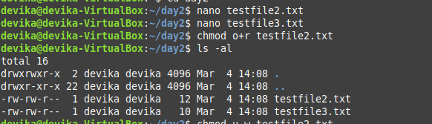

ii. revoke write from owner

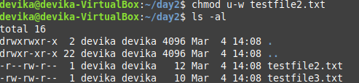

iii. set only execute to Group.

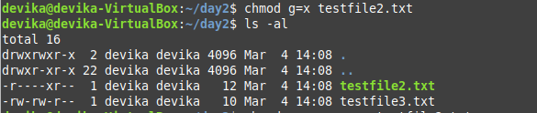

iv. add write to owner, revoke read from others and set read onlyto group.

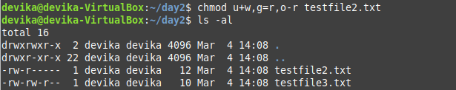

v. set read and write to all

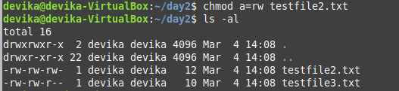

(b) Modify the permissions of testfile3 using numeric mode
i. Set read and write to all

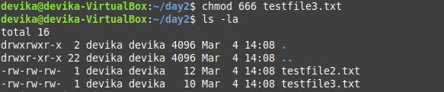

ii. set read,write and execute to owner, read and execute to group and read only to others

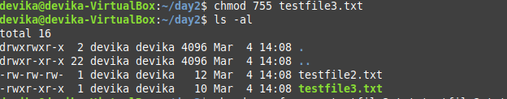

(c) Set the permissions of testfile2 the same as that of testfile3

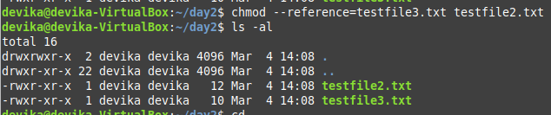

(d) Set the permissions of the tree (the directory, its children , grand children, etc.) rooted at
dir1 (Qn. 3) directory to 664

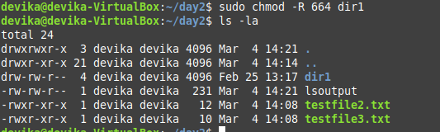

7.Change the owner and group of the directory tree from dir2 to student.

sudo useradd -m student

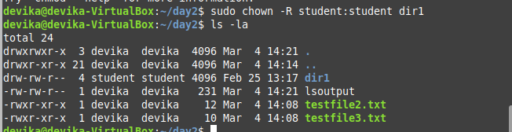

8. Display the current directory
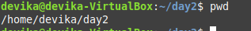

9. Listing files and folders
- List the contents of dir1(Qn.3) and all its descendants

- List the contents of dir3(QN.3) in
- Alphabetic order
- Sorted on time of modification, newest first
- Sorted on size
- Reverse order
- Long listing of files sorted on size with smallest first
- Displayed in human readable form

10. a) Execute ls and store the output to a file lsoutput
b) Execute ls -l and add the output to lsoutput, at the end.

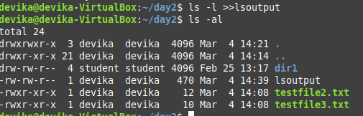

11. Execute ls -l and feed the result to less command, to scroll through the directory listing.

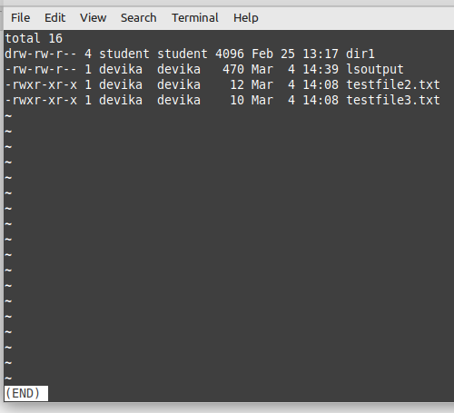

12. (a) Create a file file1 containing the word ”Hello,” using cat and output redirection
(b) Create another file file2 containing the word ”, Greetings!!”
(c) Display the sentence,
Hello,
Your name, Greetings!!
using cat, by concatenating file1, Standard Input and file2

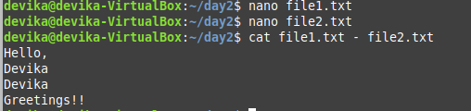

13.Copy the file file1 to newfile.
(a) If newfile already exists, it should be replaced.

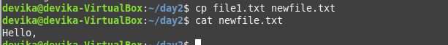

(b) If newfile already exists, it should not be replaced.

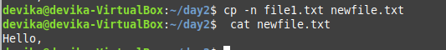

(c) If newfile already exists, it should be replaced, but only with the
consent of the user.

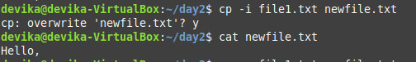

(d) If newfile already exists, it should be replaced only if its contents is
older than that of newfile.
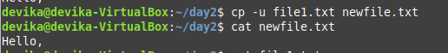

(e) Even if newfile is read only.

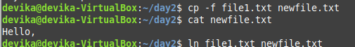

(f) Create a link instead of copying.

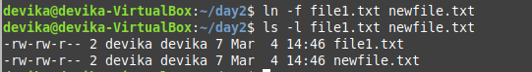

(g) Copy the entire directory tree from dir1 of Cycle 1 to a new directory dir5

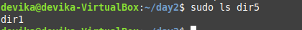

14. Create a new directory, dir6 inside dir1
(a) Move all files in dir5 into it.

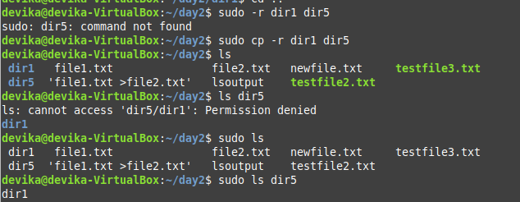

(b) Rename the file newfile in Qn.4 to oldfile

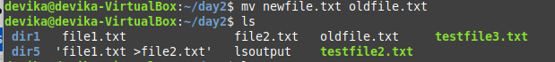

(c) Move the file file1 in Qn.4 to dir6 with the name file3

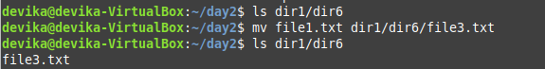

(d) Delete all files where name starts with a vowel character, upper or
lower case.

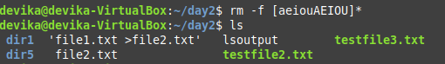

(e) Delete all files where the name is at least 3 characters long.

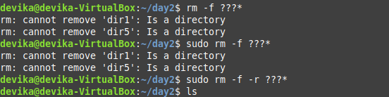
(f) Delete all hidden folders, and files.

